Incorrupt Bodies
Of the Saints

"You will not allow your holy one to see corruption" - Ps 15.
TABLE OF CONTENTS
Brief Introduction.
Saint Silvan, Martyr.
Saint Clare of Assisi.
Saint Zita.
Saint Clare of Montefalco.
Saint Agnes of Montepulciano
Blessed Margaret of Castello.
Blessed Imelda Lambertini.
Saint Rita of Cascia.
Saint Catherine of Bologna.
Saint Germaine Cousin.
Saint Vincent De Paul.
Saint Margaret Mary Alacoque.
Saint Veronica Giuliani.
Saint Theresa Margaret.
Saint Jean Marie Vianney.
Saint Catherine Laboure.
Saint Bernadette Soubirous.
Saint Maria Mazzarello.
Saint John Bosco.
Saint Maria Goretti.
Brief Introduction
The incorrupt bodies of these saints are simply a living witness or proof to the truth of the Catholic religion as the one true faith from God, who has confirmed the testimony of the Church in the great miracles he has worked through it's saints.

The Council of Trent:
"The bodies of holy martyrs and others now living with Christ, bodies which were His members and temples of the Holy Spirit, which one day are to be raised up by Him and made glorious in everlasting life, are to be venerated by the faithful; God gives men many benefits through them."

The Bodies of the saints for us are like great and holy relics, which move us to honor the saints who God has chosen to honor by preserving them incorrupt.
In scripture we read that the use of the bones of Elisha brought a dead man to life: "So Elisha died, and they buried him. Now bands of Moabites used to invade the land in the spring of the year. And as a man was being buried, lo, a marauding band was seen and the man was cast into the grave of Elisha; and as soon as the man touched the bones of Elisha, he revived, and stood on his feet." (2 Kgs. 13:20-21).
A woman was cured of a hemorrhage by touching the hem of Christ's cloak (Matt. 9:20-22). The sick were healed when Peter's shadow passed over them (Acts 5:15-16). "And God did extraordinary miracles by the hands of Paul, so that handkerchiefs or aprons were carried away from his body to the sick, and diseases left them and the evil spirits came out of them" (Acts 19:11-12).
The Power of the relics to work miracles doesn't come from the object itself but from God, who confirms the faith of the person who is healed by means of them as to testify to the holiness of His saints.

Saint Silvan, Martyr

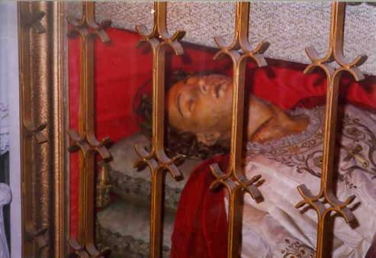

Not much is known about this beautiful saint except that he was martyred in the fourth century. Look closely at the picture and you can see a large slice in his neck, an obvious clue to his martyrdom. Also you can see an embroidered cross on the front of his garment indicating that he may have been a priest or some other cleric. St Silvan’s magnificently incorrupt body can be viewed in the Church of St. Blaise at Dubrovnik, Croatia.

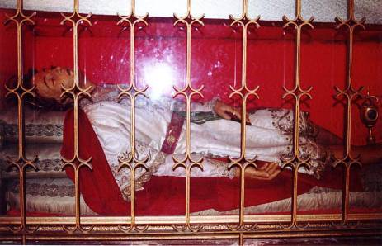

Saint Clare of Assisi

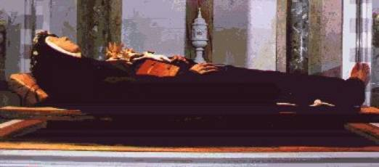

St. Clare was the Cofoundress of the Order of Poor Clares and the first Abbess of San Damiano. She was born at Assisi, Italy, on the 16th of July in the year 1194, the eldest daughter of a rich family. At an early age she gained a great distaste for worldly affairs; and when she was eighteen years of age, greatly encouraged and aided by the great St. Francis of Assisi, she decided to leave the world and join a convent. Late at night, on the 20th of March in the year 1212, Clare left for the monastery without her parents’ permission. St. Francis and his disciples met her with lighted candles in their hands. Clare then laid aside her rich dress; and St. Francis, having cut off her hair, clothed her in a rough tunic and a thick veil. In this way the young heroine vowed herself to the service of Jesus Christ. When her parents discovered her departure, her father, in a violent effort to bring her home, immediately followed her to the monastery. But Clare refused to return to the worldly life from which she had just departed.

Clare first joined the Benedictines, but later she and other fugitives from the world began the order of the Poor Clares in a rude dwelling adjoining the chapel of San Damiano.

In 1234, when the army of Frederick II was devastating the valley of Spoleto, the soldiers made an assault upon Assisi. They scaled the walls of San Damiano by night, spreading terror among the community. Calmly rising from her bed, Clare took the ciborium from the little chapel adjoining her cell and proceeded to face the invaders at an open window against which they had already placed a ladder. As she raised the Blessed Sacrament on high, the soldiers who were about to enter the monastery fell backward as if dazzled; and the others who were ready to attack took flight.

St. Clare died in Assisi on the 11th of August in the year 1253. On September 23, 1850, her coffin was unearthed and opened. The flesh and clothing of the saint had been reduced to dust, but the skeleton was perfectly incorrupt. Her bones may be seen in the crypt at Santa Chiara, Italy.

Saint Zita

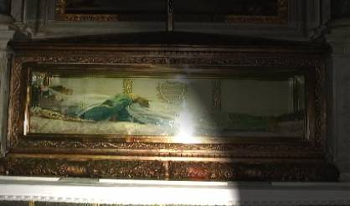

Zita was born in the beginning of the thirteenth century at Montsegradi, a village near Lucca, Italy. Her mother raised her with the fear and love of the Lord, and at an early age she was very devoted to prayers and self-mortifications. She did all with the intention of honoring the good God that created her.

When Zita was still young, she went to Lucca to work as a maid for a rich family. She would awaken early in the morning and give herself to prayer; and before it was time for work, she would hurry to attend daily Mass. For her, God always came first. During her day of work, amidst trials and tribulations, there was never heard any complaint from her lips.

Her fellow servants became very jealous of her and were mean to her at every opportunity. Because she would not complain to her master, the other servants tormented her even more cruelly. But God greatly rewarded Zita’s daily offerings of humility.

Zita died on the 27th of April in the year 1272, being sixty years old. One hundred and fifty miracles that were wrought in behalf of those who had recourse to her intercession have been juridically proved.

Her body was found, whole and entire, in 1580; and it is kept with great respect and is richly enshrined in St. Frediano’s Church in Lucca, Italy, next to the Fatinelli house where she worked for forty-eight years. Her face and hands, uncovered, can be viewed through the crystal glass. Pope Leo X granted an office in her honour, and the city of Lucca pays a singular veneration to her memory.

Saint Clare of Montefalco

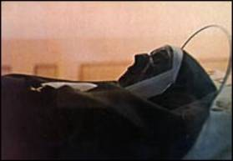

Born in 1268 into a wealthy family in Montefalco, Italy, Clare was a lively, sincere, and intelligent child. While still very young, she chose Christ as her one true love. Following her elder sister Joan’s example, Clare began the demanding practice of religious self-denial; and the two young women spent days in prolonged sessions of prayer and exceptional mortification of the flesh. Clare’s parents permitted her to live with Joan in a hermitage not far from their home. In June of the year 1290, this hermitage was declared a monastery to be governed by the Rule of St. Augustine.

Clare was chosen to be the monastery’s abbess; and for sixteen years she served as mother, teacher, and spiritual director of her nuns. Soon Clare’s reputation for holiness and wisdom attracted many visitors to the monastery. Clare, gifted with the spirit of prophecy and the grace of working miracles, frequently conversed with Our Lord. In 1294, at the age of twenty-six, Clare asked Christ, “Where are You going, Lord?” He answered, “I have been searching the whole world over for a strong place to plant My Cross, but I have found none.” Later He told her, “Clare, I have finally found a place for My Cross. I shall place it in your heart.” And from that day on, Clare’s whole body ached with acute pain. Once she said to her sisters, “If you seek the Cross of Christ, take my heart; there you will find the suffering Lord.” By July of the year 1308, Clare’s illness had become so severe that she was bedridden. On August 17, after confessing her sins to the monastery chaplain, she died.

After her death her heart was removed from her body; and a cross and the other instruments of Christ’s passion were found, clearly imprinted on the cardiac tissue (see picture below). The incorrupt body of St. Clare is preserved together with her heart with the miraculous imprints at the Church of the Holy Cross in Montefalco, Italy.

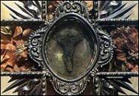

Saint Agnes of Montepulciano

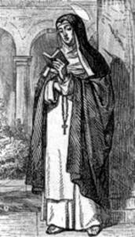

Blessed Margaret of Castello

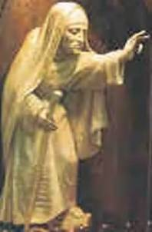

Blessed Margaret (1287-1320) was born a hunchback, a midget, blind, lame, and unattractive according to the world. When she was six years of age, her proud, noble parents walled her up in a room beside a chapel. She could not escape, but could attend daily Mass and receive the sacraments.

After fourteen years of imprisonment, she was taken to a shrine by her parents who were hoping for Margaret’s cure. But when no cure was forthcoming, they abandoned her. Margaret then became a lay Dominican and spent the rest of her life in prayer and works of mercy. When she died at age thirty-three, the townspeople thronged to her funeral and demanded that “the saint” be buried in a tomb inside the church. The priest protested; but when a crippled girl was miraculously cured at the funeral, the people’s demand was granted. Blessed Margaret’s body is still incorrupt and lies under the main altar in the Church of St. Domenico at Citta-di-Castello, Italy.

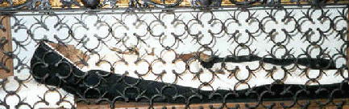

Blessed Imelda Lambertini

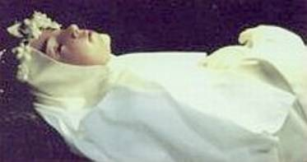

Imelda, daughter of Count Egano Lambertini and Castora Galuzzi, was born in the year 1322 at Bologna, Italy. At an early age Imelda’s heart was turned toward God. Even though she lived in the days when it was not permitted to receive the Holy Eucharist until the age of fourteen, young Imelda’s greatest desire was to receive Our Lord in the Blessed Sacrament. Oh how she longed and longed to receive Our Lord! When Imelda was under ten years old, she begged her father to allow her to enter the Dominican convent; and after much pleading, he finally consented to her desire.

Once in the convent, she again began to plead to receive Communion. Time and time again she received the same disappointment. “No, Sister Imelda, you are too young…” At the convent she took on many odd jobs. She attended the gate for the poor, she scrubbed the floors, and she did all that was asked of her—all for the honor and glory of almighty God.

On the 12th of May in the year 1333, when attending Mass with all of her Sisters, Imelda had the strongest desire to receive Our Lord. At the end of Mass, when all of the Sisters were leaving, they noticed Sister Imelda lovingly gazing toward the locked tabernacle. Some of the nuns looked at Imelda and noticed something white hovering above her. It was a Host. The nuns immediately notified the priest, who hurriedly came and carefully took the Host out of the air and placed It on a paten. Then he had no choice but to give the Host to Imelda. It was obviously God’s Will that she receive her first holy Communion. This first reception also proved to be her last; the rapture with which she received Our Lord was so great that it burst her heart. Imelda sank to the ground, unconscious. And when loving hands upraised her, it was found that she was dead. Blessed Imelda is the Patroness of First Communicants; and her beautifully incorrupt body can be seen in the Church of St. Sigismund at Bologna, Italy.

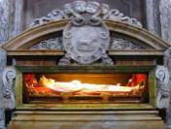

Saint Rita of Cascia

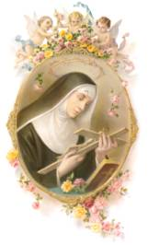

Rita was born in the year 1381. When Rita was fifteen, her parents, against her wishes to become a nun, chose a fiancé for her; and Rita unhappily consented to marriage. Her husband was a cruel and heartless man who often beat her, and their two sons soon learned many of their father’s wicked ways. Rita’s husband died a violent death but lived long enough to repent before he died, thanks to her fervent prayers. Her two sons died at an early age, but not before they repented and received the Last Sacraments, again thanks to Rita’s prayers.

Now that she was free to do with her life what she had always wanted, she became an Augustinian nun. At the age of sixty years old, when she was praying before a Crucifix, a small wound appeared on her forehead as though a thorn from Christ’s crown of thorns had penetrated her own flesh. For the last 16 years of her life, Rita bore her external and painful sign of stigmata, her union with Christ. She died on May 22, 1457.

Her body has been beautifully incorrupt for more than five hundred years. Recently the caretakers of her body were forced to lightly wax part of her face, but this did not change the beauty of this great miracle from God. Her body can be seen in the Basilica of St. Rita in Cascia, Italy.

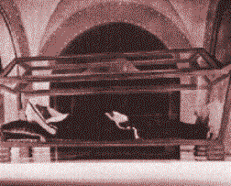

Saint Catherine of Bologna

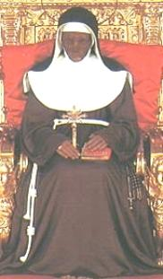

St. Catherine of Bologna was born on March 9th in the year 1413. She was born as Catherine de Vigri, the daughter of a diplomatic agent of the Marquis of Ferrara. At the age of eleven, she was appointed “maid of honor” to the daughter of the Marquis and shared in her training and education. When the Marquis’ daughter eventually married, she wanted Catherine to remain in her service; but Catherine, at the age of fourteen, left the court and became a Franciscan Tertiary.

Catherine, who had determined to live a life of perfection, was greatly admired for her holiness. Eventually her Community became part of the Poor Clares. She soon began to experience visions of Christ and of Satan and wrote of her experiences, one of which occurred on Christmas day. Through her efforts with Pope Nicholas V, the Poor Clare convent at Ferrara erected an enclosure; and Catherine was then appointed Superioress. The Community’s reputation for its holiness and austerity became widespread, and thus Catherine was later appointed Superioress of a new convent in Bologna.

In Lent of the year 1463, Catherine became seriously ill and died on March 9th. Buried without a coffin, her body was exhumed eighteen days later because of cures attributed to her and because of the sweet scent coming from her grave. Her body was found to be incorrupt and remains so today in the Church of the Poor Clare convent in Bologna. Catherine was canonized in the year 1712. Several years after her death, Catherine appeared to a nun at the convent with the request that her incorrupt body be placed in a sitting position. Her body has now grown dark due to the lighted candles that once surrounded her body.

Saint Germaine Cousin

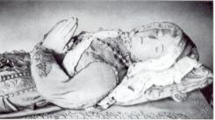

Germaine was born in the year 1579 in a tiny French town called Pibrac. From her birth she seemed marked for suffering, having come into the world with a deformed hand and the disease of scrofula. While yet an infant, Germaine lost her mother; but her father soon remarried. Under the pretense of saving the other children from the contagion of scrofula, his second wife persuaded the father to keep Germaine away from the homestead; and thus the child was employed as a shepherdess, making her home in the stable with the animals.

Germaine learned to practice humility and patience and was gifted with a marvelous sense of the presence of God and of spiritual things. To poverty, bodily infirmity, the rigors of the seasons, and the lack of affection from those in her own home, she added voluntary mortifications and austerities, making bread and water her daily food. Because of her great love for Jesus in the Blessed Sacrament, she assisted daily at the Holy Sacrifice of the Mass; and Germaine’s flocks, left to the care of Providence while she was away, suffered no harm from the wolves in the forest nearby.

The Rosary was her only book, and her devotion to the Blessed Virgin was so great that Germaine would fall on her knees at the first sound of the Angelus bell. On several occasions when Germaine crossed the river to attend Mass at the village church, the swollen waters opened and afforded her passage without wetting her garments. Her father, at last coming to a sense of duty, forbade his wife to treat Germaine harshly and offered the young shepherdess a place in their home with the other children—an offer Germaine humbly refused. Early one morning in the summer of 1601, her father found that she had not risen at the usual hour. When he went to call her, he discovered her dead body lying on her pallet of vine-twigs; Germaine was dead at the age of twenty-two. She was buried in front of the pulpit in the parish church of Pibrac.

In 1644, when her grave was opened to receive one of her deceased relatives, the body of Germaine was discovered fresh and perfectly preserved. Her body was then exposed for public view until a noble lady presented the church a casket of lead to hold the remains of the young saint. This lady was immediately cured of a serious ailment, this being the first of a long series of wonderful cures wrought at Germaine's relics. The leaden casket was placed in the sacristy; and in 1661 and again in 1700, the remains of this saint were viewed and found to be fresh and intact by the vicars-general of Toulouse. Expert medical evidence declared that the body had not been embalmed, and experimental tests showed that the preservation was not due to any property inherent in the soil. In 1793 a Revolutionary tinsmith and his three accomplices, desecrating Germaine’s casket and taking out her remains, buried them in the sacristy and threw quicklime and water on them. Even after the Revolution, Germaine’s body was found to be intact except where the quicklime had done its work. Although Satan tried to destroy God’s miracle, Germaine’s body still remains incorrupt and can be seen in the Church of Pibrac, France.

Saint Vincent De Paul

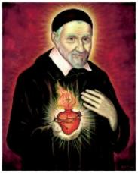

St. Vincent de Paul was born of a peasant family at Pouy, Gascony, France, in 1580, and worked as a shepherd boy on his father’s farm. At a young age Vincent had a great desire to become a priest; and after completing his studies for the priesthood, he was ordained in 1600 and remained in the vicinity of Toulouse, acting as a tutor while continuing his own studies.

Having traveled to Marseilles for an inheritance and sailing home to Toulouse, Vincent was captured by Turkish pirates in the year 1605 and was taken to Tunis. He was maltreated and eventually sold as a slave; but he escaped two years later with his master, a renegade whom he eventually converted to Catholicism. Upon his escape from the Turkish pirates, Vincent immediately dedicated his life to the practice of spiritual and corporal works of charity. He set up many poor houses for the crippled and sick and personally cared for the patients who had the most contagious diseases. He would dress their wounds and nurse them back to health; indeed there wasn’t a poor man that didn’t know of Vincent’s kindness.

On the 27th of September in the year 1660, Vincent died at the age of eighty, having faithfully served God throughout his whole life. On August 13, 1729, Vincent was declared a Blessed by Benedict XIII; and on June 16, 1737, he was canonized by Clement XII. St. Vincent’s bones and heart are perfectly incorrupt and have been placed inside a wax figure of his body. His relics can be seen in the Church of St. Vincent de Paul in Paris.

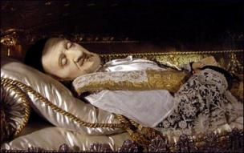

Saint Margaret Mary Alacoque

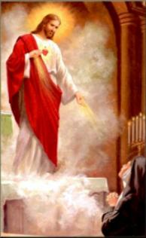

Margaret Mary Alacoque was born on the 22nd of July in the year of 1647 at L'Hautecourt, Burgundy, in France. When she was young, Margaret was healed from a crippling disorder by a vision of the Blessed Virgin, which prompted her to give her life to God. In 1671, after receiving a vision of Christ fresh from the Scourging, she was moved to join the Order of the Visitation at Paray-le-Monial, France.

Margaret received many revelations from our Lord during her lifetime, and one of these revelations included 12 promises for those who practice a true devotion to His Sacred Heart. The devotion encountered violent opposition, especially in Jansenist areas, but has now become widespread and popular.

St. Margaret Mary Alacoque is the patroness of devotees to the Sacred Heart, patron saint of polio patients, and patroness in the case of the loss of parents. Her incorrupt heart and brain have been preserved in a wax and metal figurine of her body and can be seen in the convent chapel of the Order of the Visitation at Paray, France.

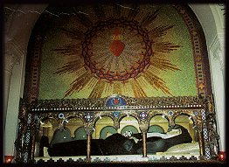

Saint Veronica Giuliani

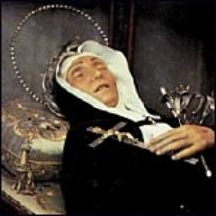

Veronica, named Ursula at her baptism, was born at Mercatello in the Duchy of Urbino, Italy, in the year of 1660. At a young age she showed marvelous signs of sanctity; and when only eighteen months old, she uttered her first words to upbraid a shop man who was serving a false measure of oil, saying distinctly: “Do justice, God sees you.” At the age of three years, she began to be favored with Divine communications. And as a young girl, showing great compassion for the poor, she would set apart a portion of her food for them and was even willing to part with her clothes when she met a poor child scantily clad.

When she became of age, her father urged her to marry and found several suitors for her; but Ursula desired to become a nun instead. Because of her father’s opposition to her desire to enter a convent, Ursula fell ill and only recovered when he gave his consent. In 1677 she was received into the convent of the Capuchin Poor Clares in Citt` di Castello, taking the name of Veronica in memory of the Passion. At the conclusion of the ceremony of her reception, the bishop said to the abbess: “I commend this new daughter to your special care, for she will one day be a great saint.” Veronica became absolutely submissive to the will of her directors, though her novitiate was marked by extraordinary interior trials and temptations to return to the world.

During the time of her temptations and interior trials, Veronica had a vision of Christ bearing His cross and henceforth suffered an acute physical pain in her heart. In 1693 she entered upon a new phase in her spiritual life when she had a vision of the chalice, symbolizing the Divine Passion which was to be re-enacted in her own soul. At first she shrank from accepting this cross, and only by great effort did she eventually submit. She then began to endure intense spiritual and physical suffering.

In 1694 she received the impression of the Crown of Thorns, the wounds being visible and the pain permanent. By order of the bishop she submitted to medical treatment, but obtained no relief.

For thirty-four years she was novice-mistress and guided the novices with great prudence. In 1716 she was elected abbess; and while holding that office, she enlarged the convent. After her death the figure of the cross was found impressed upon her heart. She was canonized in 1839 by Gregory XVI. Her body remains beautifully incorrupt and can be seen at the Monastery of St. Veronica Giuliani in Citt` di Castello, Italy.

Saint Theresa Margaret

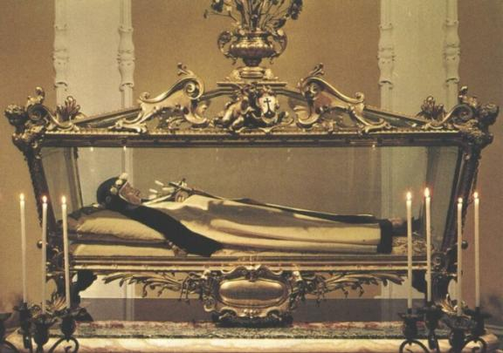

Teresa Margaret, born of the noble Redi family in Arezzo in Tuscany, Italy, in 1747, entered the Discalced Carmelites at Florence while she was yet quite young. She was given a special contemplative experience concerning the words of St John, “God is love”; and thus she deeply felt that her vocation was to live a hidden life of love and self-sacrifice. This vocation, confirmed by her heroic exercise of fraternal charity, was soon completed when she died in 1770 at the young age of twenty-three.

Immediately after her death, her body began to decompose. In a very short time her whole complexion had turned to a dreadful green color. The nuns in the convent hurriedly prepared Teresa Margaret’s body for burial; but as they were preparing to put her body into the ground, the green color miraculously was changed to her original skin coloring. She looked as though she had died only seconds before! Her body is still incorrupt and can be seen in the nuns’ choir in the Convent of Carmel in Florence, Italy.

Saint Jean Marie Vianney

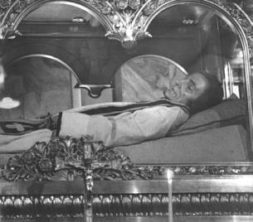

Jean Marie Vianney was born in France on the 8th of May in the year 1786. His godly mother raised him with the fear and love of the Lord. Having been raised during the French Revolution, Jean was deeply impressed with the bravery of the Catholic priests that would disguise themselves to give the sacraments to their little flocks. He had a very special devotion to Our Blessed Mother and begged her to one day help him become a priest. As Jean Marie grew in age, his desire to become a priest also grew more and more. Every day Jean and his mother would pray that God would give him the graces to be His servant, and every day the Devil would stand in the way of Jean’s future vocation. But in the end, God always triumphs. After many trying studies, Jean Marie Vianney finally became “Father Vianney.”

But still, the Devil had to put his filthy paws in the way. Father Vianney was not able to hear confessions because the authorities said that he was too “stupid” to give advice to anyone. Finally, after Jean’s many prayers and sacrifices, the authorities gave him permission to perform all of the functions of a priest. And as a priest he could finally save souls by giving them loving but firm guidance in the confessional.

It was soon decided that Father Vianney would be sent to a tiny French town called Ars, a town so small that no one had heard much about it. The new Curé of Ars, Jean Marie Vianney, saved many souls in Ars and won many hardened souls for Christ. People from all over Europe came to Ars just to have him hear their confessions, causing Father Vianney to frequently spend up to sixteen hours daily in the confessional. For many years Father Vianney toiled for Our Lord with the special aid of his heavenly assistant St. Philomena, working with his God-given gift of performing miracles. Then, on the 4th of August in the year of 1859, God called Jean to Himself. Europe was in mourning, knowing that they had lost one of the best confessors of all time. Jean Marie Vianney’s body was exhumed in 1904 and was found to be incorrupt. It is now in the basilica at Ars and can be viewed by the public.

Saint Catherine Laboure

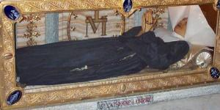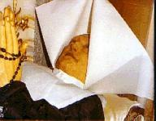

As the evening Angelus bell sounded, Catherine was born of Peter and Louise Laboure on May 2, 1806, the ninth child of a family of eleven. Fifteen minutes after Catherine’s birth, her name was entered on the city records. She was baptized on the following day on the feast of the Finding of the True Cross. It surely was God’s design that Catherine, a saint who was to be so highly favored by the Blessed Virgin, was born at the ringing of the bell for Our Lady's Angelus.

When Catherine was nine years old, her saintly mother died. After the burial service, little Catherine retired to her room and, standing on a chair, took our Lady's statue from the shelf, kissed it, and said: “Now, dear Lady, you are to be my mother.”

When Catherine was very young, she had a vision of St. Vincent de Paul and was thus persuaded to enter a convent. She entered the Daughters of Charity and was a very holy and cheerful nun; all of the sick people loved her company. Sister Catherine was very privileged, having received many apparitions from St. Vincent de Paul and, more importantly, from the Blessed Virgin Mary. One day the Blessed Mother chose to reveal to her a secret—Catherine Laboure’s heavenly mission was to create and propagate the Miraculous Medal. When the Mother of God gave Sr. Catherine the instructions for the medal, she said: “Have a medal struck as I have shown you. All who wear it will receive great graces.”

Soon people were wearing the medals and miracles began to take place; thus the medal came to be known as the “Miraculous Medal.” Many wicked men and women were converted through the graces provided by the Mother of God. In no time at all, Miraculous Medals were propagated everywhere.

Catherine died on the 31st of December in 1876; and when her body was exhumed in 1933, it was found as fresh as it was on the day it was buried. Although she had been in the grave for fifty-seven years, her eyes remained very blue and beautiful; and in death her arms and legs were as supple as if she were asleep. Her incorrupt body is encased in glass beneath the side altar at the chapel of the Daughters of Charity at 140 Rue de Bac in Paris, France, beneath one of the sites where our Lady appeared to her.

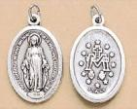

Saint Bernadette Soubirous

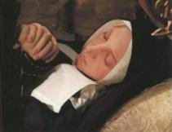<>

Bernadette, born in 1844 of very poor parents in the town of Lourdes, France, spent most of her childhood in poor health. As she grew older, she was very slow at her studies and lost much school time due to severe asthma attacks. On February 11, 1858, when Bernadette was sent with her younger sister and a friend to gather firewood, she saw a very beautiful Lady standing above a rose bush in a grotto at Massabielle. The lovely Lady, dressed in blue and white, smiled at Bernadette and then made the sign of the cross with a rosary of ivory and gold. Bernadette fell on her knees, took out her own rosary, and began to pray. The beautiful Lady was God’s Mother, the Blessed Virgin Mary. She appeared to Bernadette during seventeen other apparitions; and during one of the last of these appearances, she instructed Bernadette to go further into the grotto and begin digging in the dirt with her hands. At first nothing happened; but soon the miraculous fountain, now known as the “Fountain of Lourdes,” began to flow forth from the ground where Bernadette had dug.

At the age of twenty-two, Bernadette became a Sister of Charity at Nevers, France. Although besieged by many of the faithful, she sought God in the silence of the cloister, serving Him in humility under the vows of her profession as a Sister of Charity. She lived in the convent for thirteen years, spending a large portion of this time ill in the infirmary. When a fellow nun accused her of being a “lazybones,” Bernadette said, “My job is to be ill.”

Sister Bernadette died on the 16th of April in 1879. On the feast of the Immaculate Conception, December 8, 1933, Bernadette was canonized, thus fulfilling the promise that the Blessed Mother had made to her in 1858: “I do not promise to bring you happiness in this world, but in the next.”

St. Bernadette’s body, which to this day has never corrupted, lies in St. Gildard Convent in Nevers, France. After having been exhumed three times, her body was discovered to have slightly discolored in places; and in l925 an extremely light wax covering was made for her face and hands.

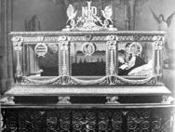

Saint Maria Mazzarello

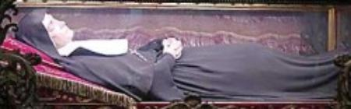

Maria Domenica was born on May 9, 1837, in Mornese (Alessandria). When she was young, she developed a solid piety and an outstanding common sense and depth of judgement that would show later in life as Congregational Leader.

At the age of fifteen, she joined the Association of the Daughters of Mary Immaculate and began her apostolate among the young people of her village. When Maria was twenty-three, a serious attack of typhoid had a profound spiritual effect on her. The experience of her own physical fragility deepened her abandonment to God and encouraged her to open a sewing school to educate the girls in work, prayer, and love of God.

Thanks to her intense sacramental life and the wise guidance of Fr. Pestarino, Maria made great progress in the spiritual life. On the occasion of Don Bosco’s visit to Mornese (October 8, 1864) she said: “Don Bosco is a saint and I feel it.” In 1872 Don Bosco chose her to begin the Institute of the Daughters of Mary, Help of Christians (the Salesian Sisters).

As Congregational Leader she proved to be a capable teacher of spiritual life, involving other young people in her dedication to the education of women. Maria was cheerful and serene, spreading peace and radiating joy wherever she went.

The Institute developed rapidly. At her death she left her Daughters an educational tradition permeated by Gospel values: “the search for God, Whom we come to know through enlightened catechesis and ardent love, responsibility in work, sincerity and humility, austerity of life and joyful self-giving.”

Maria Domenica died in Nizza, Monferrato, on May 14, 1881. Her incorrupt body is venerated in the Basilica of Mary Our Help, in Turin, Italy. Her feast day is celebrated on May 13th.

Saint John Bosco

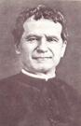

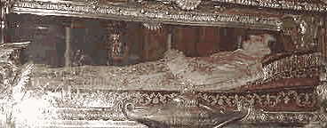

John Bosco was born in Becchi, a hillside hamlet near Castelnuovo, Piedmont, Italy, on the 16th of August in the year 1815. When John was barely two years old, his father died and left the support of three boys to the mother, Margaret Bosco. John’s early years were spent as a shepherd, and he received his first instruction at the hands of the parish priest. John possessed a ready wit and a retentive memory; and as years passed, his appetite for study grew stronger. Because of the poverty of the home, he was often obliged to turn from his books to the field; however, the desire for the religious training that he had given up never left him.

In 1835 he entered the seminary at Chieri. And after six years of study, on the eve of Trinity Sunday, Don Bosco was ordained priest by Archbishop Franzoni of Turin. Leaving the seminary, Don Bosco went to Turin where he entered zealously upon his priestly labors. It was here that the real field of charity that would be his calling until death opened up to him.

One of his duties was to accompany Don Cafasso upon his visits to the prisons of the city. The children who were confined in these places and abandoned to the most evil influences, with little before them but the gallows, made such an indelible impression upon Don Bosco’s mind that he resolved to devote his life to the rescue of these unfortunate outcasts.

On one occasion, when Don Bosco was vesting for Mass, he overheard the sacristan driving away a ragged urchin. Don called the young boy back to the church, and immediately a friendship was struck that would be the first of thousands for Don Bosco. Soon all of the young boys from the village knew that they could find a loving and trusting friend in the good priest. More and more young boys without homes began flocking to Don Bosco’s church; and in February of 1842, the “oratory” (as it had come to be called) numbered twenty boys. In March of the same year, the oratory numbered thirty; and in March of the year 1846, four hundred. Don Bosco soon had to find more room for all of these homeless boys and obtained one building after another in an effort to keep them off the street.

God called Don Bosco to Heaven on the 31st of January in the year of 1888. St. John Bosco’s incorrupt body lies in the Basilica of Mary Our Help, in Turin, Italy, next to the incorrupt body of St. Maria Mazzarello.

Saint Maria Goretti

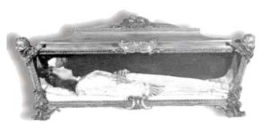

Maria Goretti was born on October 16, 1890. Her parents were sharecroppers; and in 1899 they moved to Ferrire, Italy, her father thinking that he had a better chance to find work there. Her father met the Serenelli family and made a deal in which the Goretti family could live with them.

Maria matured quite early, complained seldom, and helped her family daily with chores. Growing in her spirituality as well, Maria was very anxious to receive her First Holy Communion because of her immense love of God. She could only imagine how wonderful it would be to receive Jesus Christ in the Holy Eucharist!

However, the Serenelli’s nineteen-year-old son, Alessandro, had other plans. He cared nothing for God and receiving Holy Communion. He was possessed by the Demon of Lust and wanted to carry out his lustful plans with Maria. Several times he approached her with his sinful ideas, but every time Maria reprimanded him and told him it is a sin to be impure.

Then one day, July 5th of the year 1902, Alessandro made a sinful decision. On the morning of that fateful day, Maria had been very sick. Even so, she begged her mother to allow her to go to the fields to work. Maria knew that if she were to remain at home, Alessandro would be alone with her; but her mother insisted that she remain at home to rest. Poor Maria! She was very frightened but decided that she would be obedient to her mother’s wish instead of persisting.

As soon as her family had left, Alessandro, realizing that he and Maria were alone, raced into her room and tried to rape her. Maria resisted, all the while telling him that he was sinning and would surely go to Hell. Alessandro gave up his dirty plans of the rape and instead pulled a long, sharp knife out of his belt and stabbed Maria fourteen times.

She sank to the floor, crying, “Mamma! Mamma!” Alessandro dropped his dagger and fled from the room just before his father entered. Maria was immediately taken to the hospital. She lived for only one hour; but before she died, a priest came and heard her confession. He asked her, “Do you forgive your murderer?” Maria answered, “I forgive him with all of my heart, and I want him to come to heaven!” While gazing at a picture of Our Blessed Mother, Maria soon after expired.

Less than fifty years later, Maria Goretti was declared a saint and martyr. Both Maria’s mother and Alessandro, who had completed a thirty-year imprisonment for his crime, attended her canonization. The beautiful, incorrupt body of Saint Maria Goretti has been placed in the Church of Our Lady of Mercy in Nettuno, Italy.

Some others:

St. Cecilia, born in Rome, died in 177 A.D. at Rome; her body was found incorrupt in 1599. She is known as the first incorrupt saint, and her incorrupt body was found in the position represented by the sculptor.

St. Agatha, born in a prison, died in 250 A.D. at Catania, Sicily. She was martyred by being rolled on coals.

St. John of the Cross, born at Hontoveros, Old Castile, on the 24th of June in the year 1542, died at Ubeda, Andalusia, on the 14th of December, 1591.

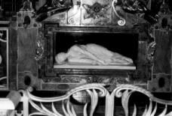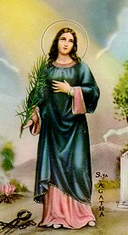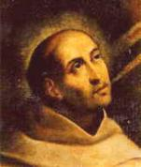

Saint Cecilia, VM St. Agatha, VM St. John of the Cross

